MARVEL TRAILERS – Mobile App

Dear Marvel Fans,

I am glad to inform you all, that from today; we will have a dedicated Android app for view our favorite Marvel videos, marvel comics, trailers, talks, reviews and everything related to Marvel.  
Its purely Marvel Madness!  
You can scroll through videos, share the app with your friends.  
  
You can also reach out to Admin asking to host your Marvel favorite video, and the request will be done at priority. This app is for the Marvel fans and you control its universe and not Thanos. Yes, you heard it, you control the content of this app.  
  
So, How does this app look -> <https://github.com/pradeep-charism/files-repo/blob/master/How_does_this_app_look_MARVEL_TRAILERS.pdf>  
  
Thank you,

Yours faithfully,

Marvel Trailers.

P.S Below pages for screenshots

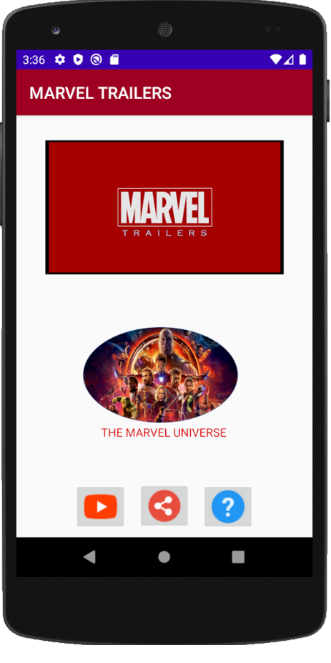 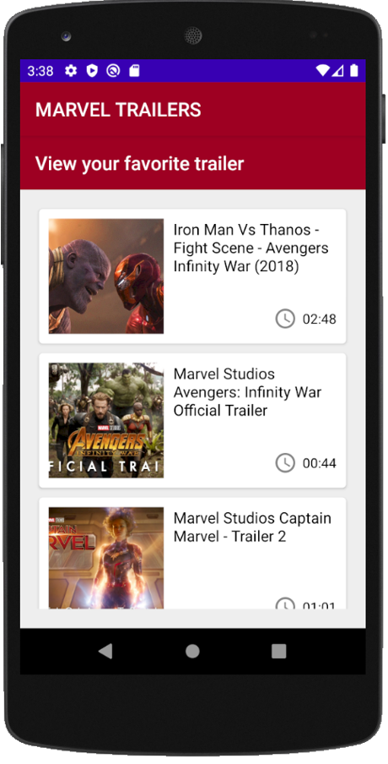

1. This is the home screen, and the video list screen.
2. This list is a recycler view list, showing thumbnails of the favorite marvel movie trailers and videos from MCU.

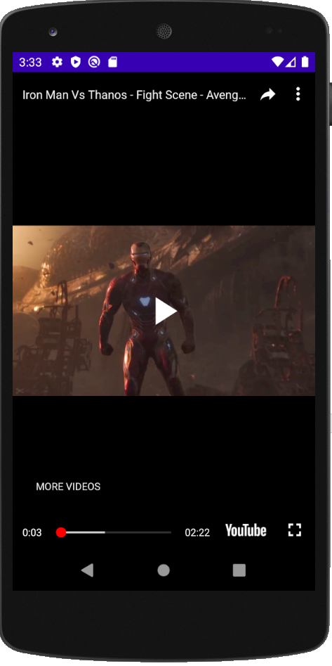 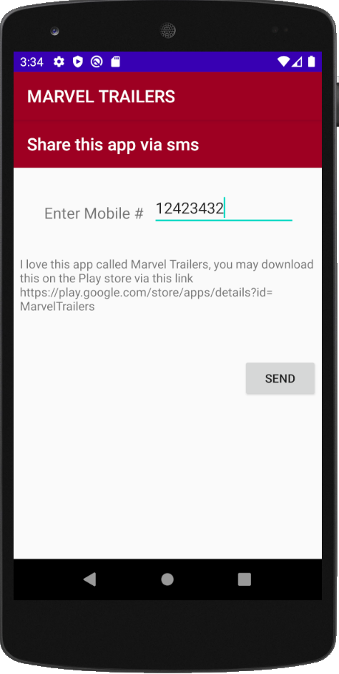

1. This screen displays, video is played on clicking any thumbnail image from the list of video screen.
2. Displays the screen to send/share this app link with your contacts.

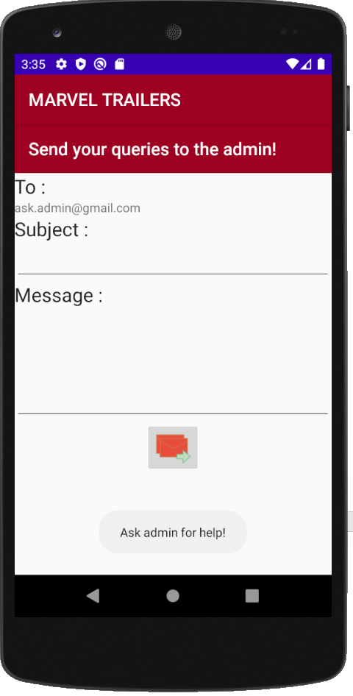

1. This screen shows, you can contact admin for help or any queries.